**SOW – Real Estate Data Visualization HTML File Generation**

**2024-10-14**

**Description:**

We are looking to have simple application that takes in Real Estate data and produces static HTML files for the purposes of data visualization (including geolocation / maps data). While the files generated should be static HTML, the user should be able to interact with the HTML in a dynamic, interactive way, as described below.

Please note that these HTML files are intended for *internal purposes* (use only within our company), which means the files will NOT be displayed as part of a website, rather they will be stored and opened locally by experienced users.

Please note that we are looking for a Minimum Viable Product developed quickly and efficiently, as opposed to a highly robust piece of sofwtare with all edge cases tested. In other words – speed of development and low cost of development is the priority.

**Developer Skills:**

We are looking for a developer with the following skills:

* Preferred libraries:
  + Python
  + Pydeck
  + Seaborn
* However, developers are free to make alternative recommendations, to be reviewed by us prior to developing the software.

**Inputs:**

* The software should accept the following data file (example provided):
  + Grand-Haven_MI_Combined_2024-10-04.xlsx

**Outputs:**

* The software should generate a static HTML file that the user can interact with as described below.

**Visualization Features:**

* The web app should have a Map at the top of the web page, as shown below.
  + The map should display all Zillow listings (rows) in BLUE, and all Airbnb listings (rows) in RED, using the GPS coordinates provided in the data.
  + 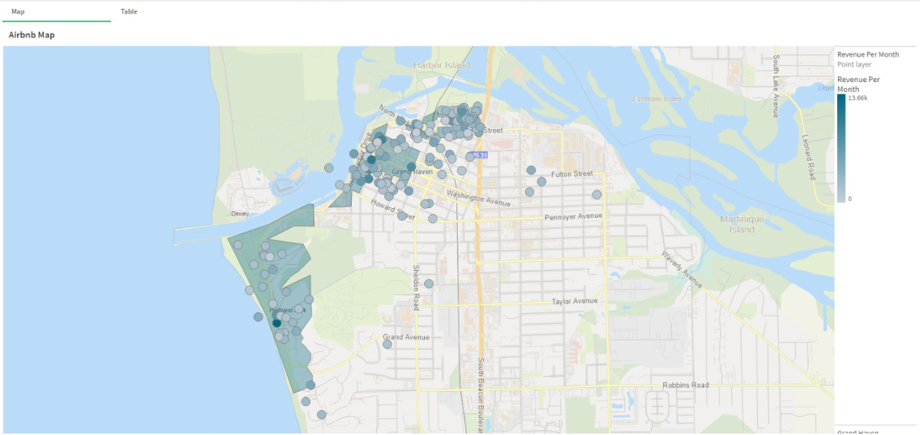
* A table view (tab or similar) must also be available to display the same information, with two (2) tabs – one each for the following Excel sheets:
  + Zillow Homes Data
  + A screenshot of a computer

    Description automatically generated
  + General Listings Info *(hereinafter referred to as “Airbnb data”)*
* The user should be able to select the data that is shown on the map in the following ways:
  + Selecting data from the tables
    - The table view should be interactive, allowing users to sort ascending/descending, and filter columns just like they would in Excel.
    - Then the user can select any/all rows they want to display on the map.
  + Global filters
    - Automatic filters on Airbnb data (applied by default, but can optionally be turned off / modified)
      * Remove all properties with days listed of <271 days
      * AND
      * Reviews Count <20
      * AND
      * If link is not currently active
    - Optional global filters
      * Zillow
        + Home type (list)
        + Date sold (date)
        + Home cost (two entries for min/max)
      * Airbnb
        + Percentile annual revenue (two entries for percentage – 0-100%)

E.g., you have already filtered for 3 bedroom homes only, now you want to look at top 50th percentile of these.

* + - * + Days listed (line between 0-max value)
* Graphs (to be displayed below the map)
  + Zillow
    - Average Price Sold vs. # of Bedrooms and Bathrooms
    - 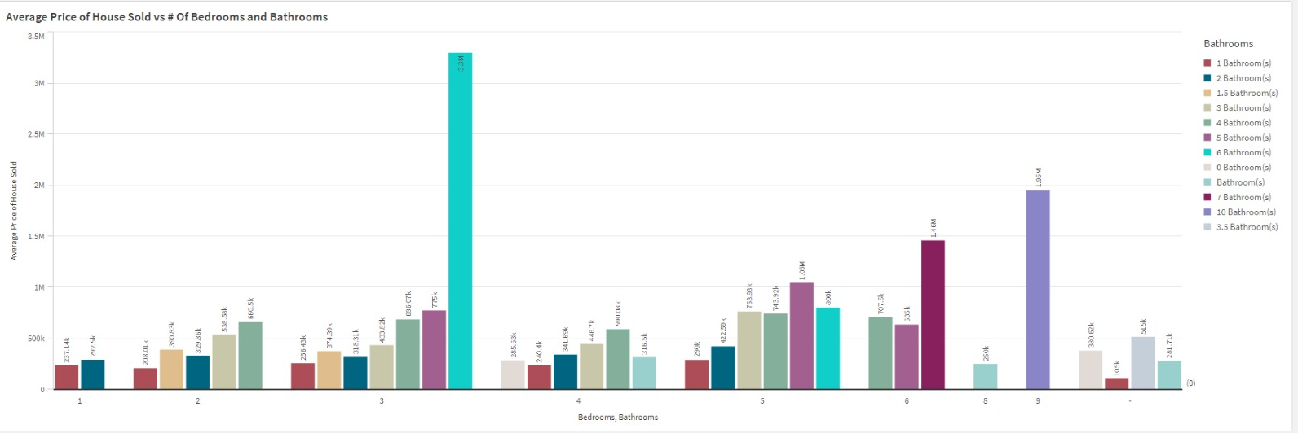
  + Airbnb
    - Distribution of Average Revenue Per Month (based on # of bedrooms)
    - 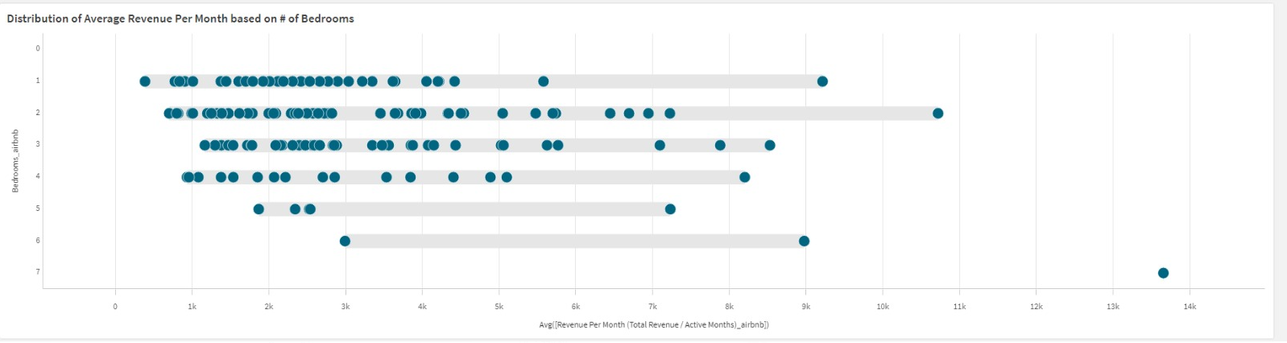
    - Average Revenue Per Month vs. # of bedrooms (include count of available Airbnbs)
    - 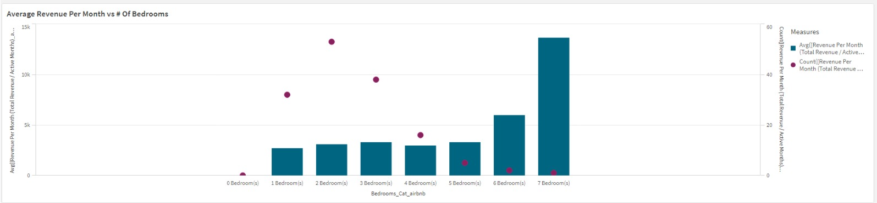
* The following KPIs displayed at the top of the web app (above the map):
  + Calculated results for entire data selected, Zillow and Airbnb:
    - 

**Development Process:**

* Prior to software development, developer to provide:
  + Simple mock-up / visualization of the web app.
    - This does *not* need to be fancy – just a simple layout diagram in PowerPoint or similar will suffice. The purpose is to confirm mutual understanding of what should be developed, and allow us to make layout modifications before software is developed.
  + Brief description of their understanding of the project, corresponding to the layout.
    - Language should be specific – including describing which sheets/columns in the data source will be displayed, and how they will be displayed.
  + List of questions / uncertainties / open items the developed would like answered.
* Version 1 is developed, and example outputs are provided / tested.
  + We will then provide feedback and request modifications, as needed.
* Version 2 is developed, and example outputs are provided / tested.
  + Is this is sufficient, job is complete, and source code will be requested.

**Deliverables:**

* All source code must be provided.
* Example software outputs and a brief video (screen recording) explaining how to use the software.